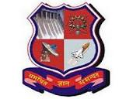


Ahmedabad Institute of Technology,
Ahmedabad-380060 (Gujarat) INDIA.

GUJARAT TECHNOLOGICAL UNIVERSITY

G

RESUME: B.E.ELECTRICAL

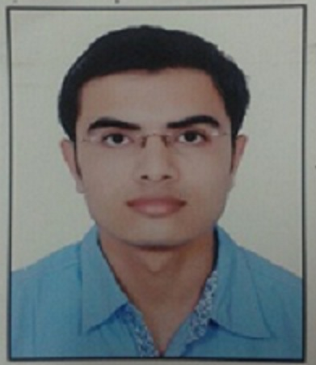

Photograph

- OBJECTIVE:

To work in a company that will give me an opportunity for self development, to be contributed in the progress of the company. To remain seek a position where I can contribute in the field of Electrical & satisfy my dedication to work on different projects.

Reserved Category (if any): OPEN

(1) Name in Full: DHOLAKIA DHWANIL SUBHASHBHAI (As per 10+12 marksheet)

(2) Address for Correspondence:

Permanent Address

‘‘SURJYOT’’ 16/A NEW SANSKAR NAGAR,
NEAR ROTARY HALL,
BHUJ-KACHCHH
370001

- PERSONAL CONTACT DETAIL

Mobile: 9408246559 (R) 9428214561
7405732692

E-mail: dhwanildholakia7@gmail.com

(3) Date of Birth: 04/07/1993 Age: 24 YEARS

Height: 5”6’

(4) Gender: MALE

(5) Academic History (Pre-Engineering):

Examination | Board | Year of Passing | % Marks Obtained
X | V.D.HIGH SCHOOL-Bhuj  (GSEB) | 2008 | 69.69
XII | KRISHNA INTERNATIONAL SCHOOL-Rajkot  (GSHEB) | 2010 | 63.20

- Academic Record (Engineering): (2010-2014)

SEM NO. | SPI | CPI | CGPA
7 | 7.29 | 5.60 | 6.07
8 | 7.63 | 5.95 | 6.65

- CURRENT STATUS:

- Worked at MSTPL (MUNDRA SOLAR TECHNOPARK PVT. LTD) of ADANI Group, Mundra-Kachchh Gujarat since 6th November 2015 to 30th September 2017 as Associate Electrical Engineer in Execution (Project Site).

- 220/66 kV Substation extension.
- 66 kV Transmission Tower Erection & 66 kV Transmission Line.
- Switchgear Control Room Erection, testing of various equipments like Breakers, Transformers, HT-LT Panels & other distribution panels.
- Underground 66 kV & 11 kV Cable Laying & Power Distribution.
- Office area sockets, Domestic sockets, lighting & UPS-Data arrangements by underground supply line.
- Illumination work of different lights.
- Arrangement of UPS & Row Power in manufacturing site.
- Commissioning of Goods & Passenger Lifts, different Solar cell manufacturing Machines.
- Primary Training of 66 kV Gas Insulated Substation.
- Daily DG Monitoring & Maintenance (5 kVA & 125 kVA)

- PREVIOUS PLANT PROFILE :

- As Graduate Apprentice Trainee at ADANI POWER LTD. MUNDRA (4620 MW) from 13 Nov, 2014 to 12 Oct, 2015.

I got training in 400 kV Switchyard, 330 MW & 660 MW Main Plant, Testing, Coal Handling Plant, Balance of Plant (2 Months in each department)

- TRAINING EXPERIENCE:

I have vocational training experience in

(1) Basics on CHP (Coal Handling Plant), BTG (Boiler, Transformer, Generator) Section at
ADANI POWER LTD, MUNDRA

(2) Basics on Thermal Power Plant at ATPS-GMDC.LTD, AKRI-Pandhro

- ROLES RESPONSIBILITIES:

- Site Supervision, planning & scheduling of day to day site jobs.
- Checking of measurement in substations (220 kV & 400 kV) & Power Transformers
- Work supervision of Electrical Machines.
- Ensures compliance of procedures & checklists.

- NOTE:

- I’ve Certificate of ELECTRICAL SUPERWISER (Govt. Of Gujarat).
- Project Report on ‘‘DETECTING POWER GRID SYNCHRONISATION FAILURE ON SENSING FREQUENCY AND VOLTAGE BEYONG ACCEPTABLE RANGE’’
- I’ve done primary work on SAP Software.

- KEY SKILLS:

- Good Communication Skill & Self Confidence.
- Passionate Badminton Player.
- Mathematics.

- PERSONALITY TRAITS:

- Ability to work under require situation.
- Good Team Work capability.
- My experience from my past activity has given me the confidence to accept & overcome Challenges with my improvement in performance.

- PASSPORT DETAILS:

- Passport No: M 1870407
- Date of Issue: 04/09/2014
- Date of Expiry: 03/09/2024

I was 2nd Runner Up in Singles Category in Badminton Tournament of Shantivan Welfare Council,Mundra in Sep’15.

I am requesting & expecting to get an opportunity to explore myself more with my dedication, regularity & honesty by getting technical site as per your requirement.

- Declaration: I hereby declare that the information provided above by me is true.

SIGNATURE

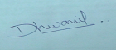

YOURS TRULY
(DHWANIL S. DHOLAKIA)

